Deltoidal Hexecontahedron

Definition
# Source: AI Source: Provided by: [Data Path: Persons Table -> ID Column: 1, Name_En Column: Motasem Essam] -> From: [ChatGPT] on [7/25/2026]
A Deltoidal Hexecontahedron is a convex Catalan solid composed of 60 congruent kite-shaped faces, also called deltoids.
It has 120 edges and 62 vertices. It is the dual polyhedron of the Rhombicosidodecahedron, an Archimedean solid.
It is also known as the Trapezoidal Hexecontahedron, Strombic Hexecontahedron, or Dyakis Hexecontahedron.

Geometric Structure
# Source: AI Source: Provided by: [Data Path: Persons Table -> ID Column: 1, Name_En Column: Motasem Essam] -> From: [ChatGPT] on [7/25/2026]
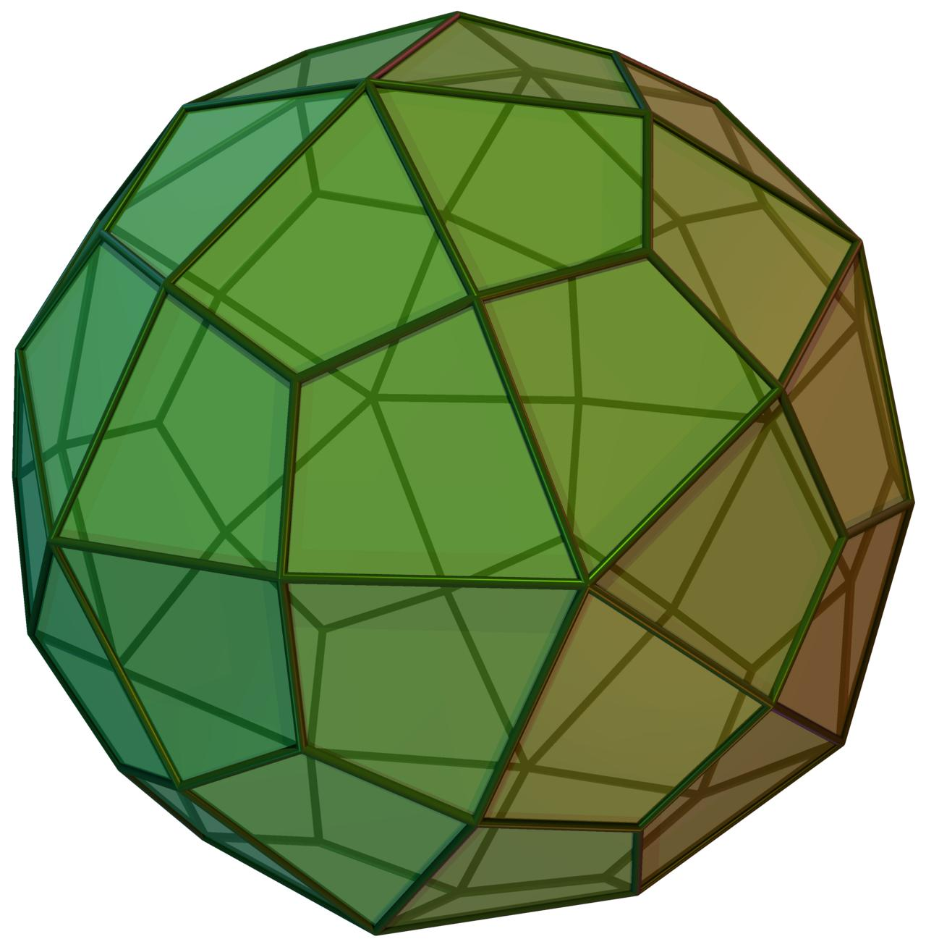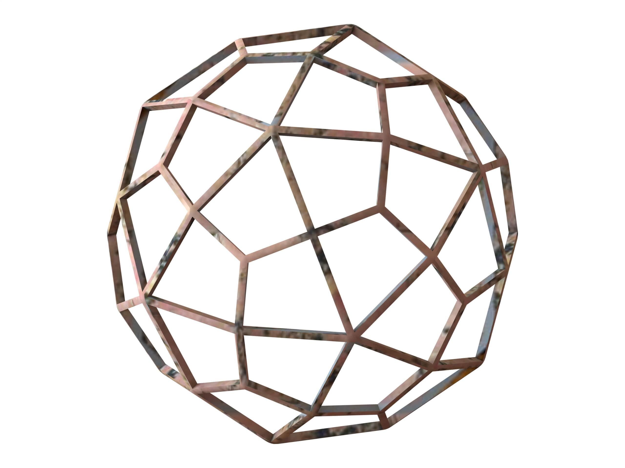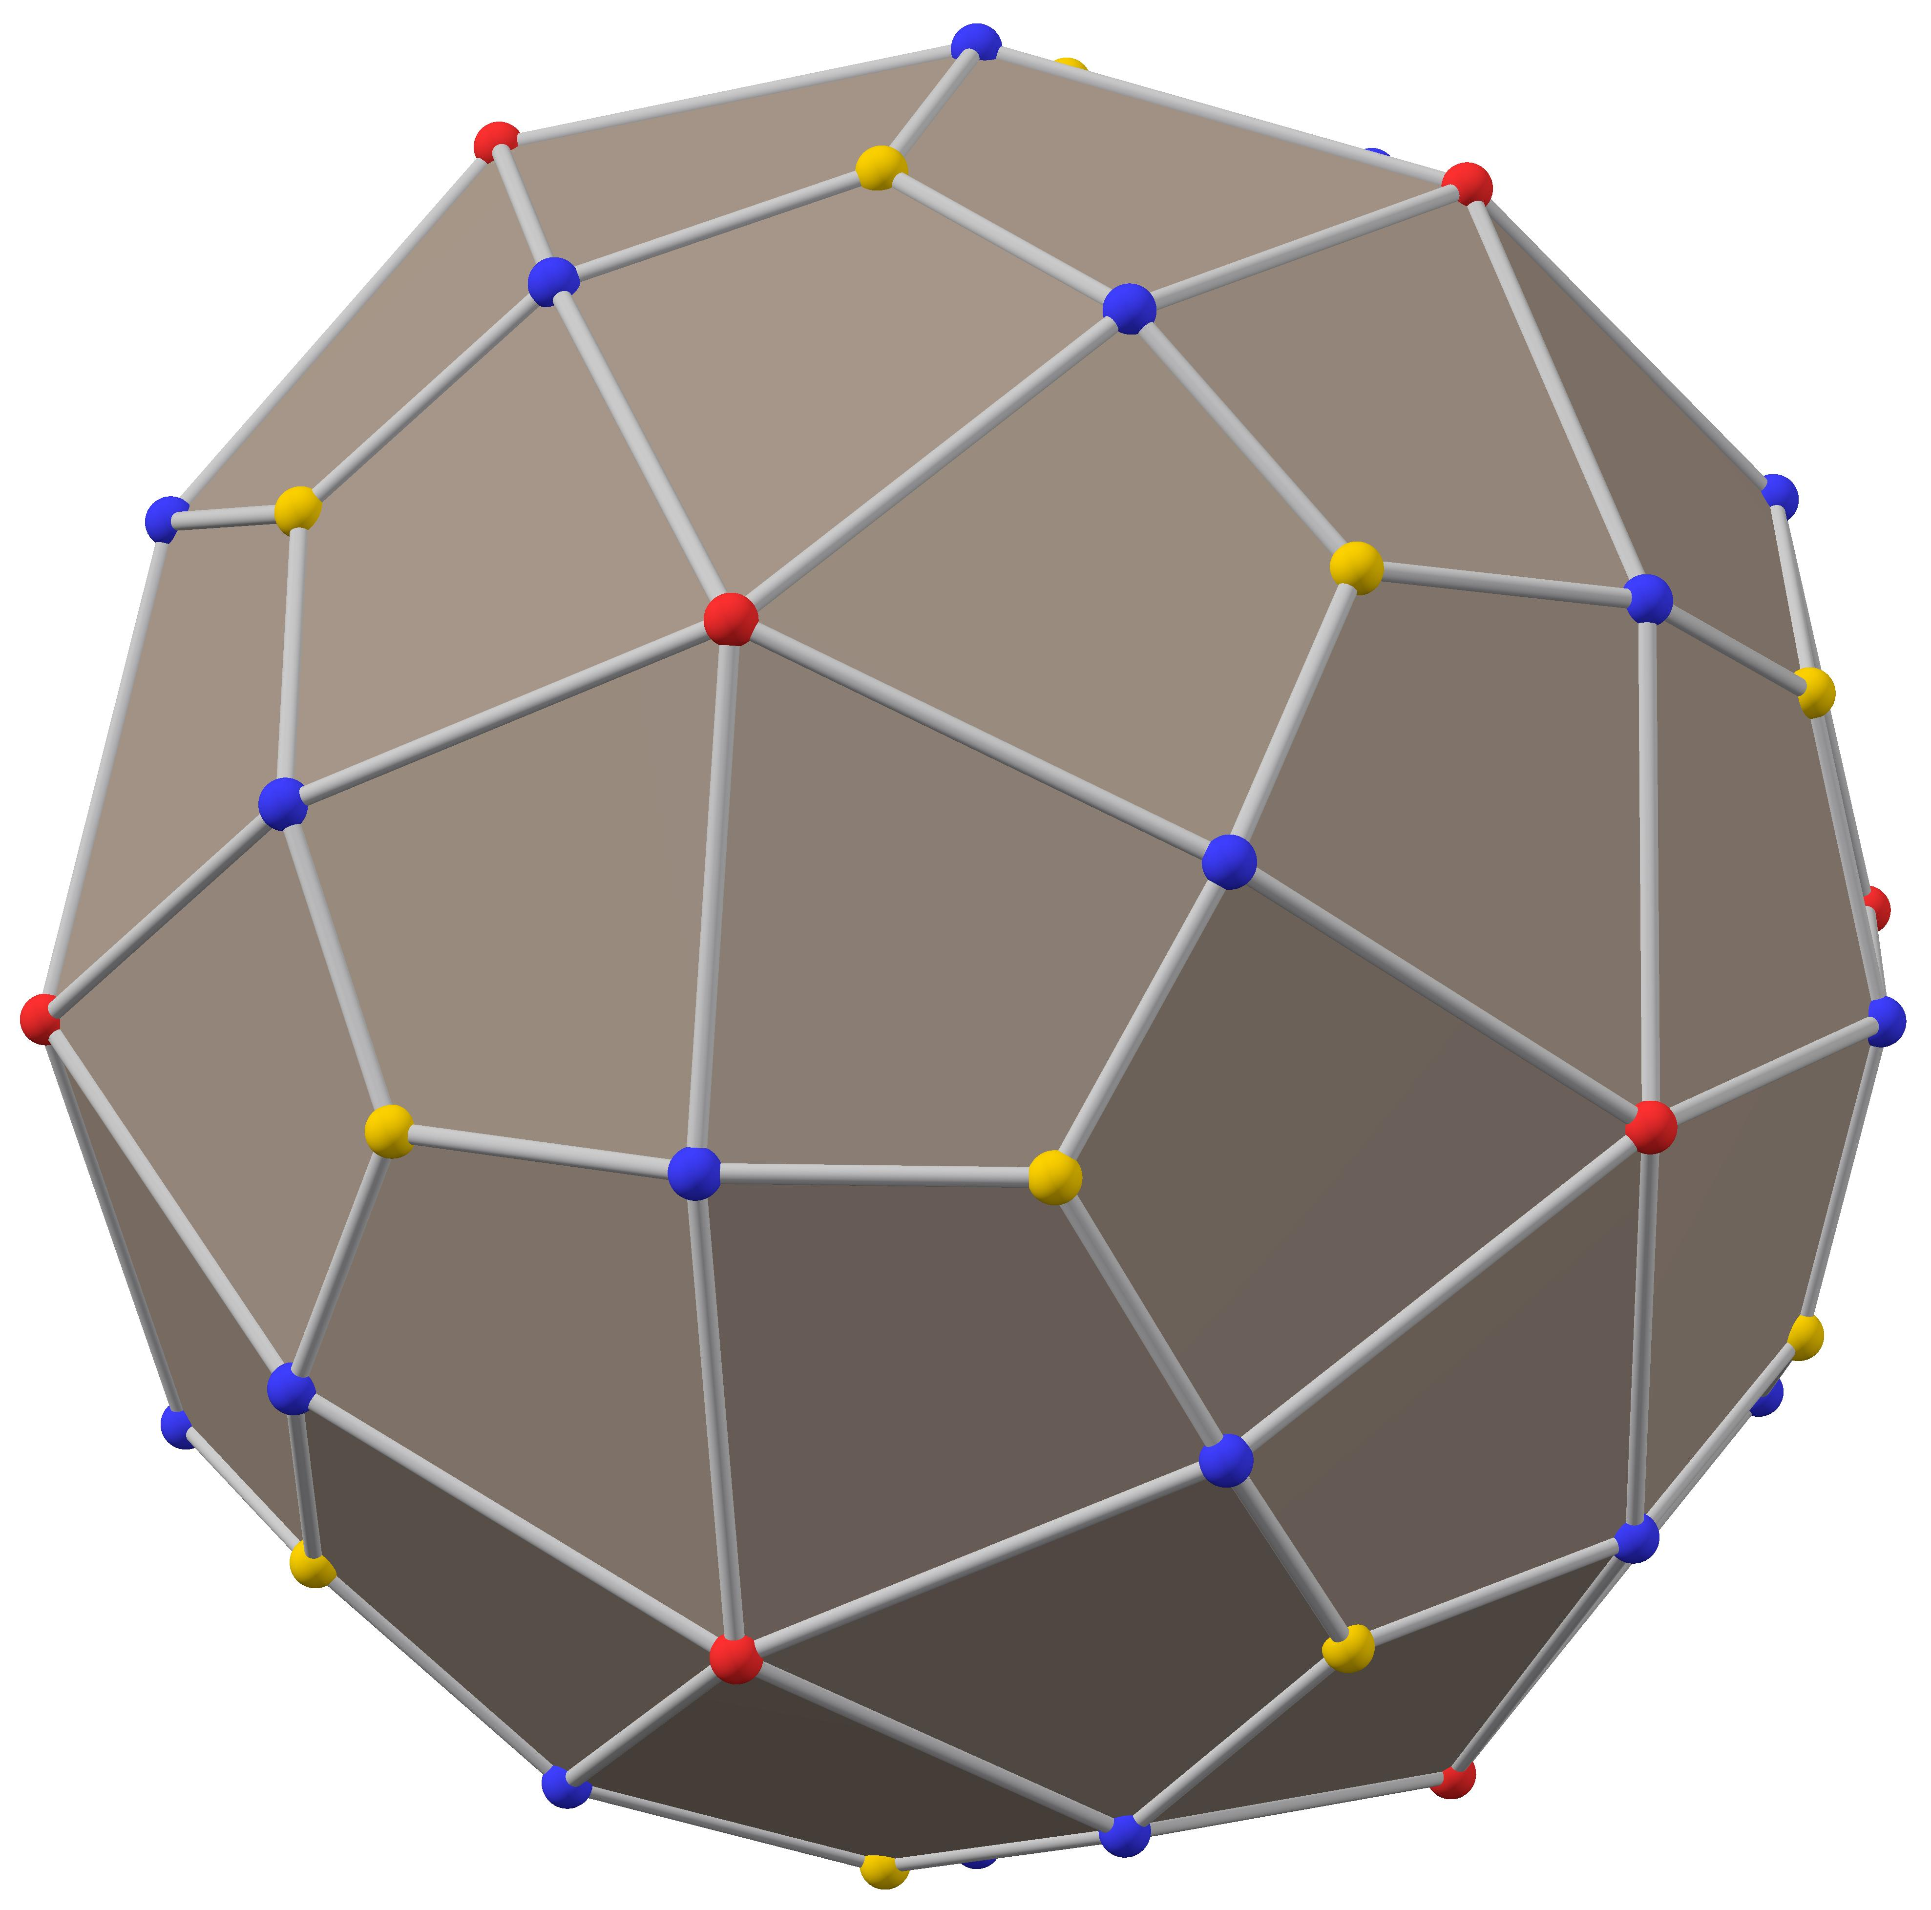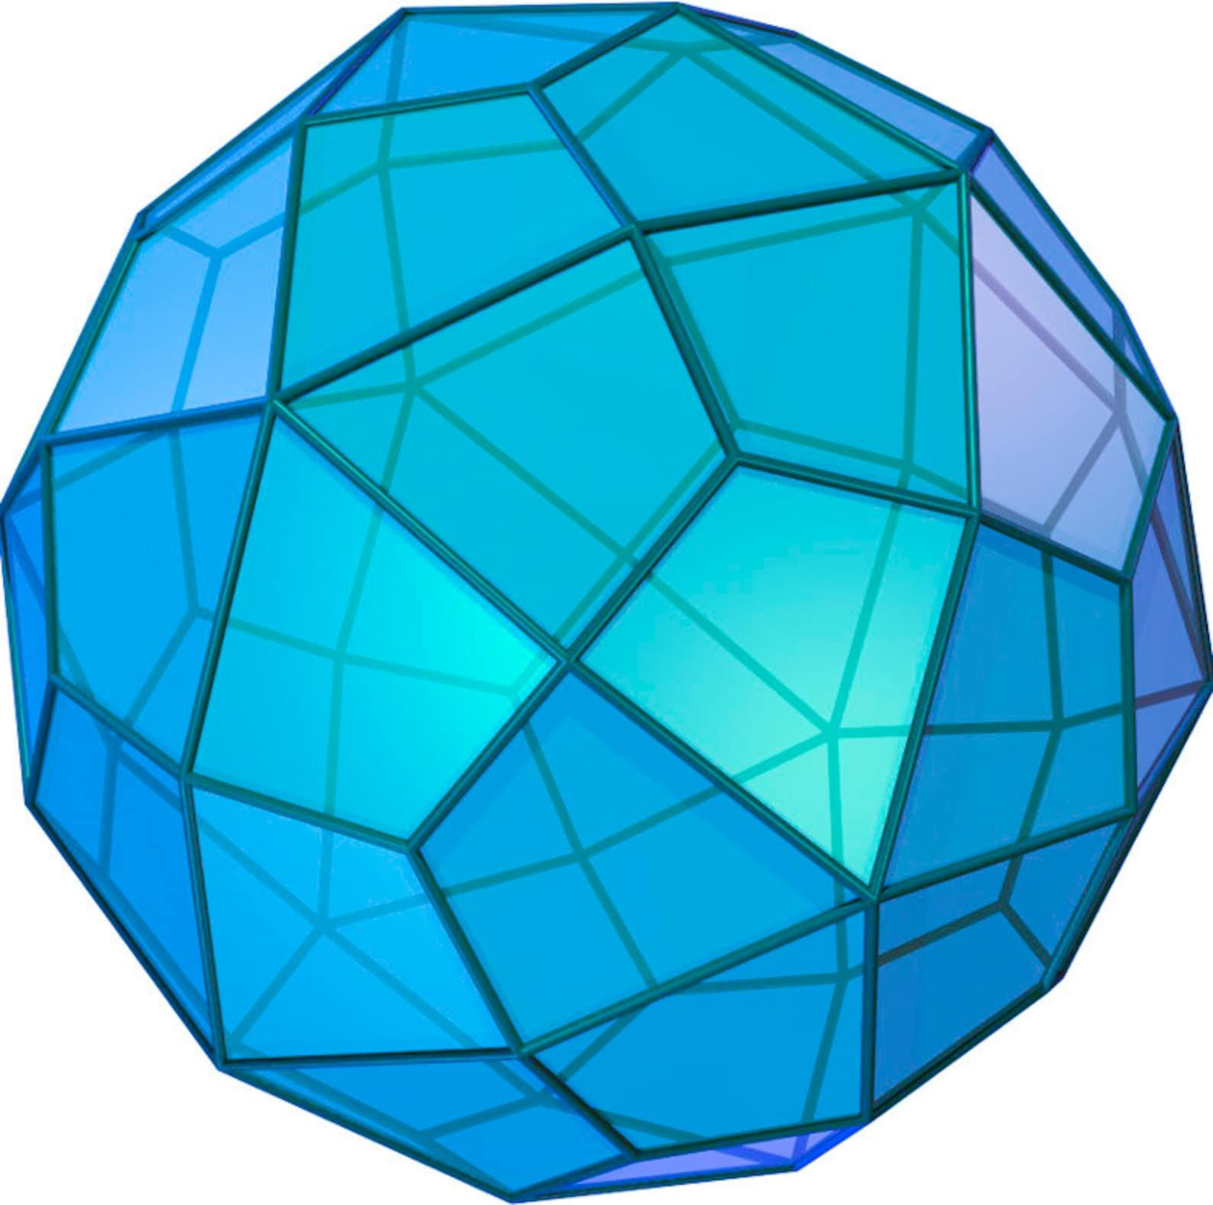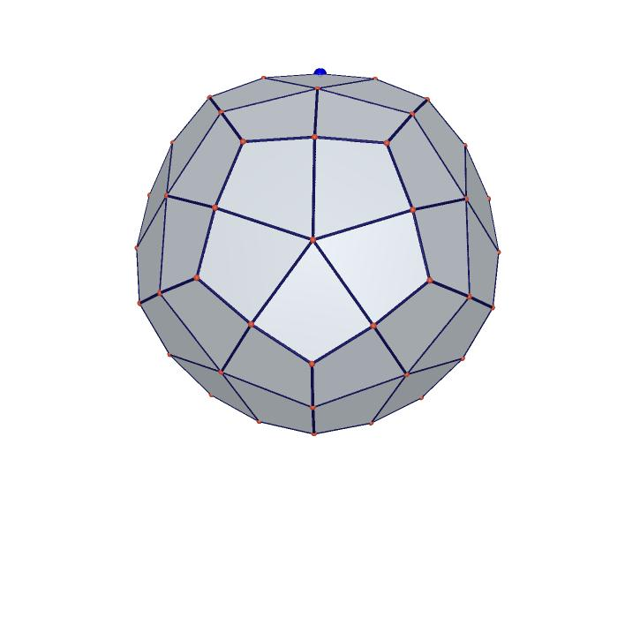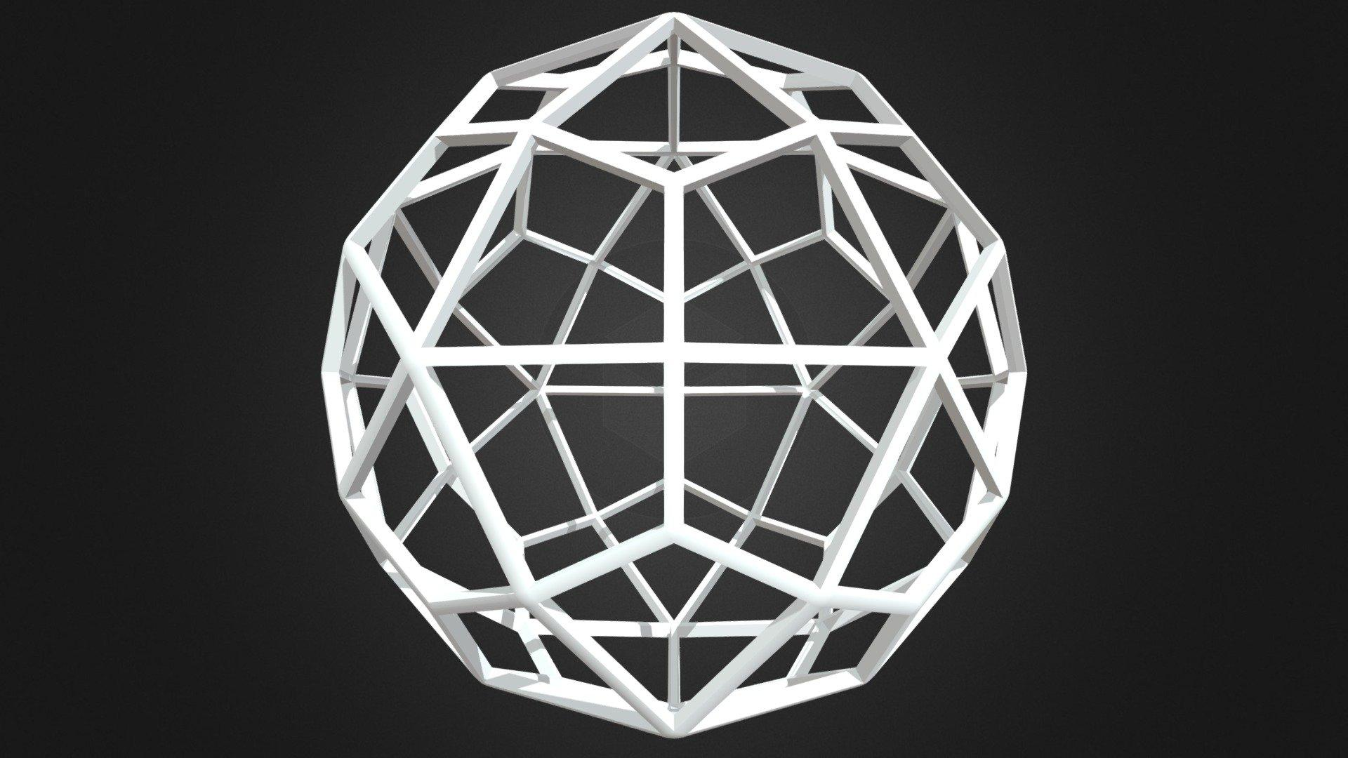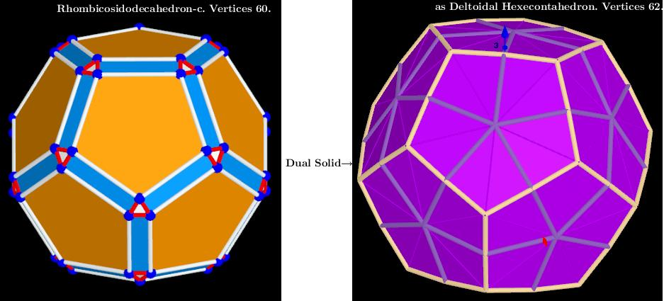
The solid consists of:
- 60 Kite-Shaped Faces: Each face is a convex quadrilateral with two pairs of adjacent equal-length sides.
- 120 Edges: Divided into 60 shorter edges and 60 longer edges.
- 62 Vertices: Divided into three groups according to the number of edges meeting at each vertex.
Unlike Archimedean solids, its faces are not regular polygons. However, all 60 kite-shaped faces are congruent.

Face Composition
# Source: AI Source: Provided by: [Data Path: Persons Table -> ID Column: 1, Name_En Column: Motasem Essam] -> From: [ChatGPT] on [7/25/2026]
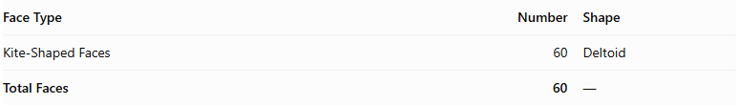
Face Type | Number | Shape
Kite-Shaped Faces | 60 | Deltoid
Total Faces | 60 | —
Each kite has:
- Two shorter edges of equal length.
- Two longer edges of equal length.
- Two pairs of equal angles.
- A shorter diagonal and a longer diagonal.

Mathematical Properties
# Source: AI Source: Provided by: [Data Path: Persons Table -> ID Column: 1, Name_En Column: Motasem Essam] -> From: [ChatGPT] on [7/25/2026]
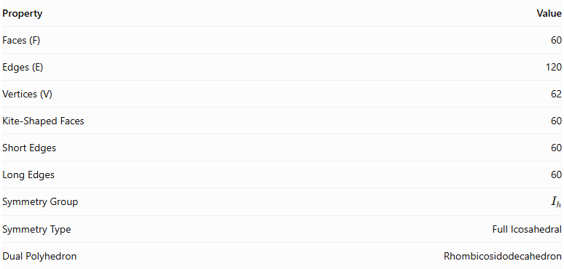
Property | Value
Faces (F) | 60
Edges (E) | 120
Vertices (V) | 62
Kite-Shaped Faces | 60
Short Edges | 60
Long Edges | 60
Symmetry Group | $$I_{h}$$
Symmetry Type | Full Icosahedral
Dual Polyhedron | Rhombicosidodecahedron
Euler's Formula:
$$V-E+F=2$$
$$62-120+60=2$$
Vertex Classification:
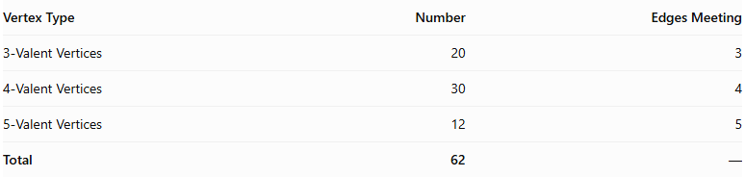
Vertex Type | Number | Edges Meeting
3-Valent Vertices | 20 | 3
4-Valent Vertices | 30 | 4
5-Valent Vertices | 12 | 5
Total | 62 | —
Edge-Length Ratio:
The ratio of the shorter edge to the longer edge is:
$$\frac{s}{l}=\frac{3\sqrt{17-7φ}}{11}$$
where
$$φ=\frac{1+\sqrt{5}}{2}$$
Approximately:
$$\frac{s}{l}≈0.650$$
Volume:
For a Deltoidal Hexecontahedron dual to a unit-edge Rhombicosidodecahedron:
$$V=\frac{100}{33}(5+4\sqrt{5})$$
$$V≈42.2554$$
The volume depends on the chosen scale of the solid.

Geometric Characteristics
# Source: AI Source: Provided by: [Data Path: Persons Table -> ID Column: 1, Name_En Column: Motasem Essam] -> From: [ChatGPT] on [7/25/2026]
- It is a convex Catalan solid.
- All 60 faces are congruent kite-shaped quadrilaterals.
- It is face-transitive, meaning all faces are equivalent under its symmetry operations.
- Its edges have two different lengths: 60 shorter edges and 60 longer edges.
- Its vertices have three different configurations: 20 vertices of valency 3, 30 of valency 4, and 12 of valency 5.
- It has full icosahedral symmetry, represented by $I_{h}$.
- Its dual is the Rhombicosidodecahedron.
- It is not an Archimedean solid because its faces are not regular polygons.

Geometric Construction
# Source: AI Source: Provided by: [Data Path: Persons Table -> ID Column: 1, Name_En Column: Motasem Essam] -> From: [ChatGPT] on [7/25/2026]
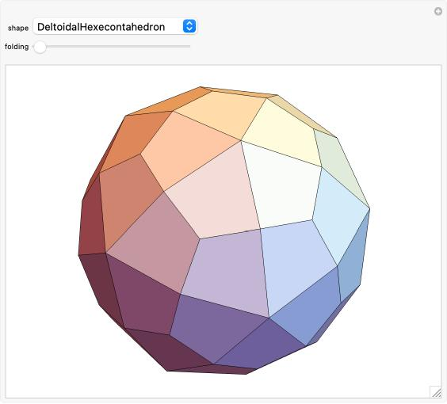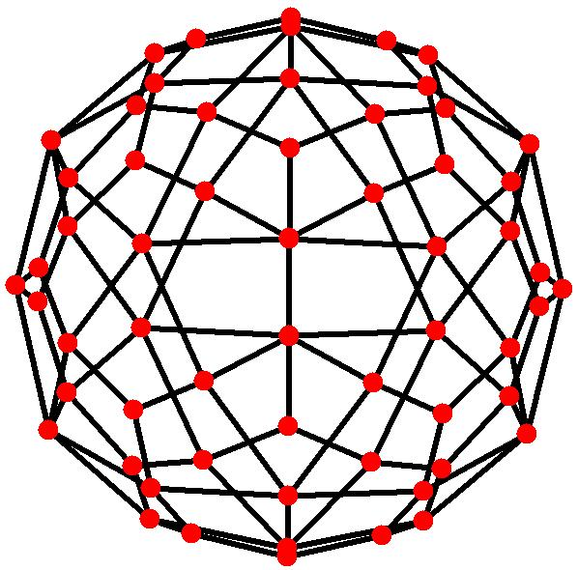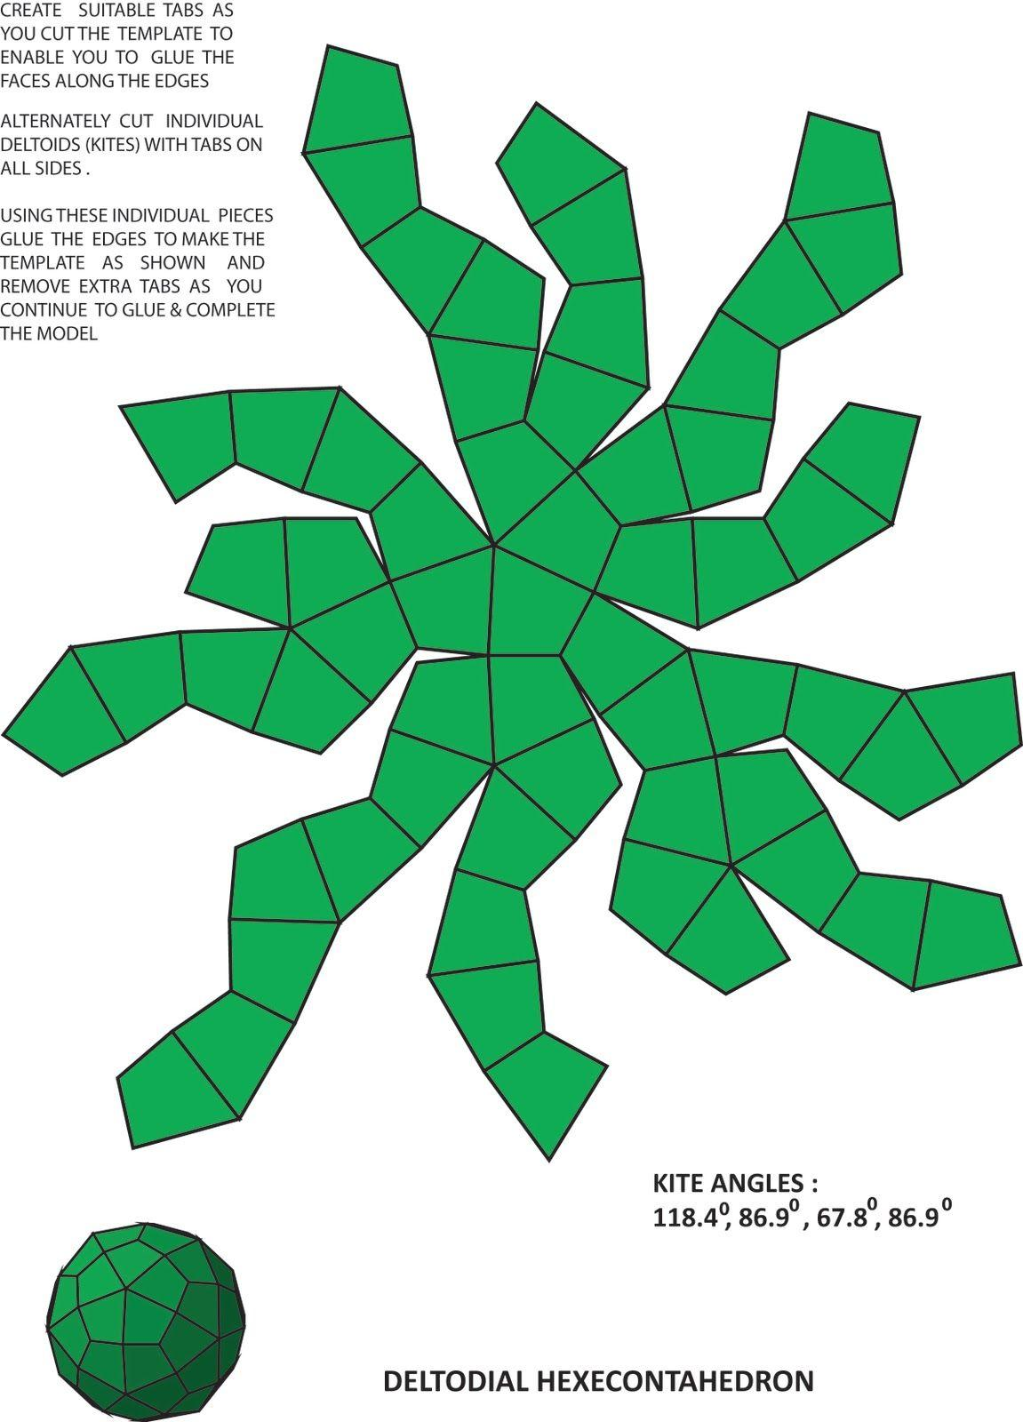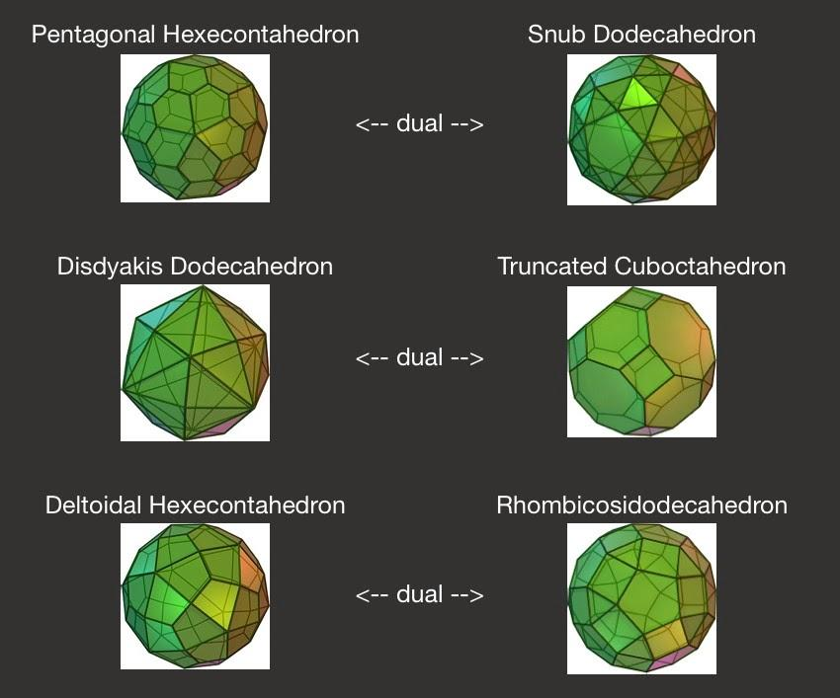
The Deltoidal Hexecontahedron is constructed as the dual of the Rhombicosidodecahedron.
The construction follows these steps:
- Begin with a Rhombicosidodecahedron.
- Locate the center of each of its 62 faces.
- Use these face centers as the vertices of the dual polyhedron.
- Connect adjacent face centers according to the adjacency of the original faces.
- Construct one kite-shaped face for each vertex of the original Rhombicosidodecahedron.
- Complete the solid to obtain 60 congruent kite-shaped faces.
The original solid's 62 faces become the 62 vertices of the dual, while its 60 vertices become the 60 faces of the Deltoidal Hexecontahedron.

Related Geometric Solids
# Source: AI Source: Provided by: [Data Path: Persons Table -> ID Column: 1, Name_En Column: Motasem Essam] -> From: [ChatGPT] on [7/25/2026]
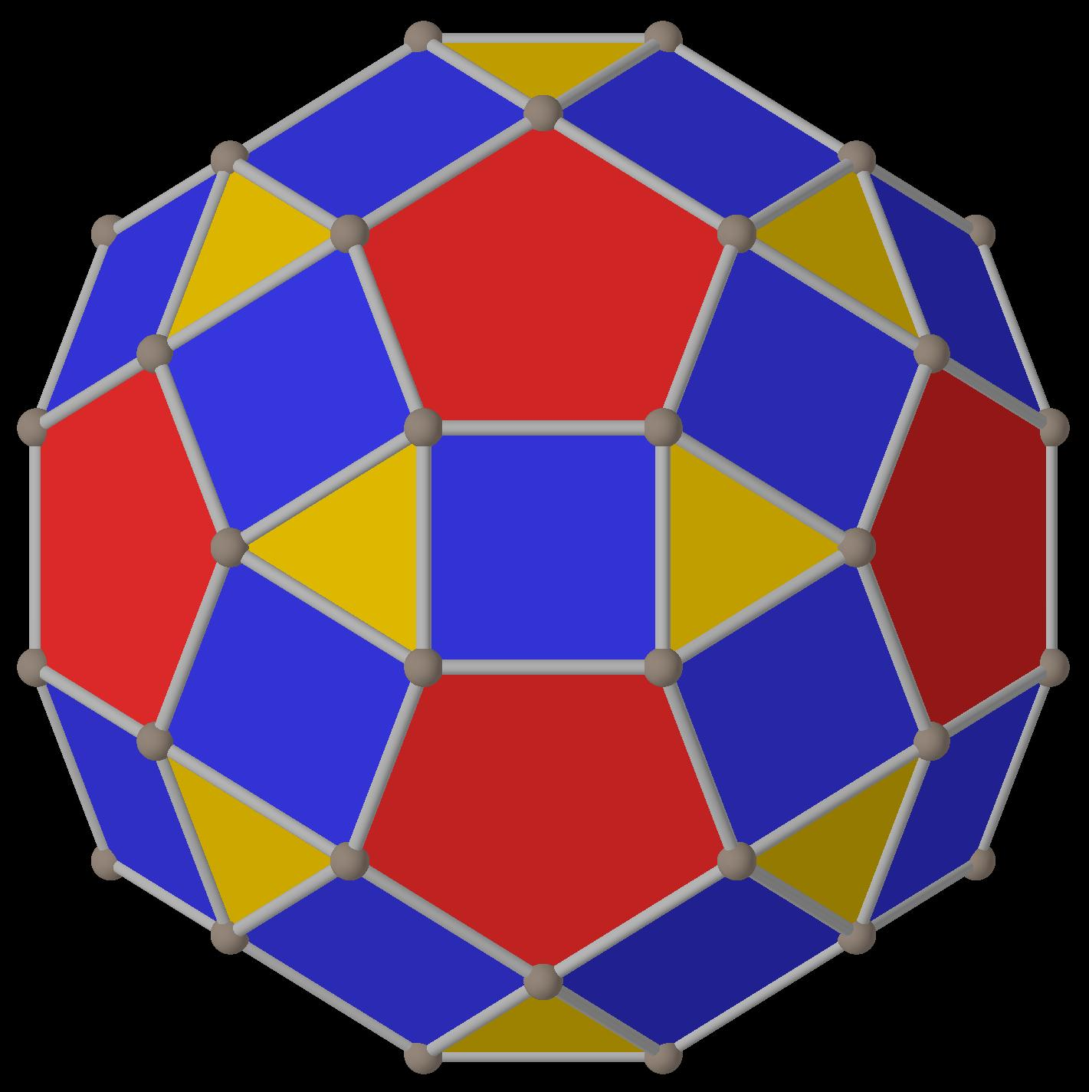
Rhombicosidodecahedron
The Archimedean solid whose dual is the Deltoidal Hexecontahedron.
Great Deltoidal Hexecontahedron
A different, nonconvex star polyhedron and the dual of the Great Rhombicosidodecahedron.
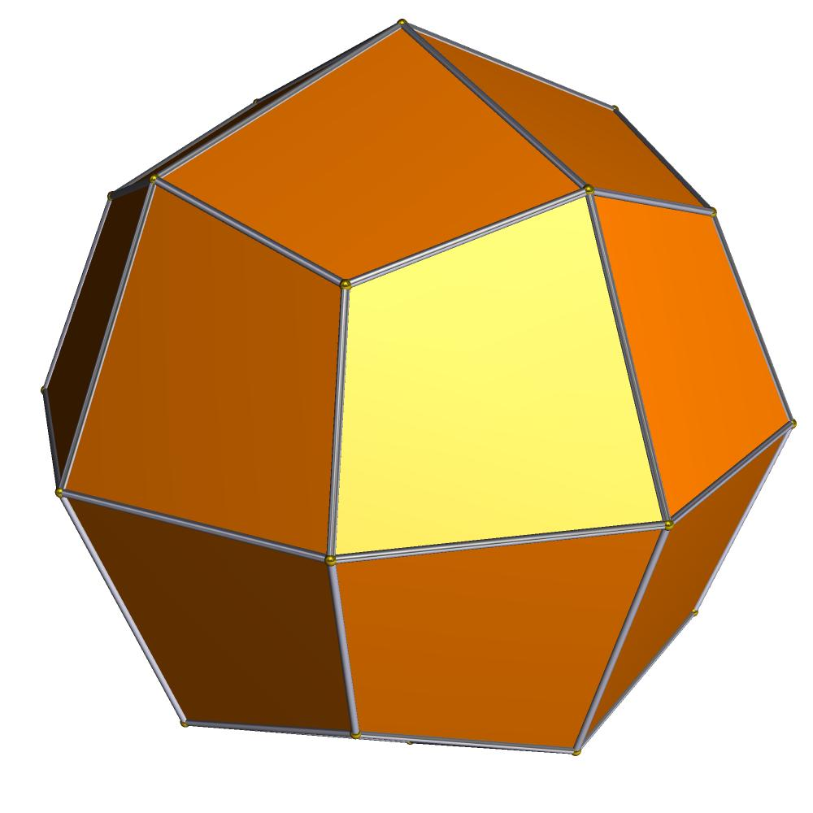
Deltoidal Icositetrahedron
Another Catalan solid, which is the dual of the Small Rhombicuboctahedron.

Construction of Deltoidal Hexecontahedron

Geometric Instruments Used
# Source: AI Source: Provided by: [Data Path: Persons Table -> ID Column: 1, Name_En Column: Motasem Essam] -> From: [ChatGPT] on [7/25/2026]
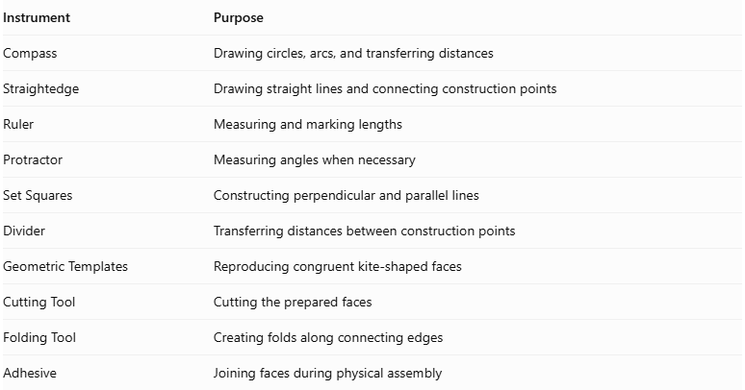
Instrument | Purpose
Compass | Drawing circles, arcs, and transferring distances
Straightedge | Drawing straight lines and connecting construction points
Ruler | Measuring and marking lengths
Protractor | Measuring angles when necessary
Set Squares | Constructing perpendicular and parallel lines
Divider | Transferring distances between construction points
Geometric Templates | Reproducing congruent kite-shaped faces
Cutting Tool | Cutting the prepared faces
Folding Tool | Creating folds along connecting edges
Adhesive | Joining faces during physical assembly

Instrument-Based Construction Procedures

Step 1: Construct the Reference Polyhedron
# Source: AI Source: Provided by: [Data Path: Persons Table -> ID Column: 1, Name_En Column: Motasem Essam] -> From: [ChatGPT] on [7/25/2026]
Use the Small Rhombicosidodecahedron as the reference solid because the Deltoidal Hexecontahedron is its dual.
- Construct or obtain a geometrically accurate Small Rhombicosidodecahedron.
- Identify its 20 equilateral triangular faces.
- Identify its 30 square faces.
- Identify its 12 regular pentagonal faces.
- Verify that its faces and edges follow the correct adjacency relationships.
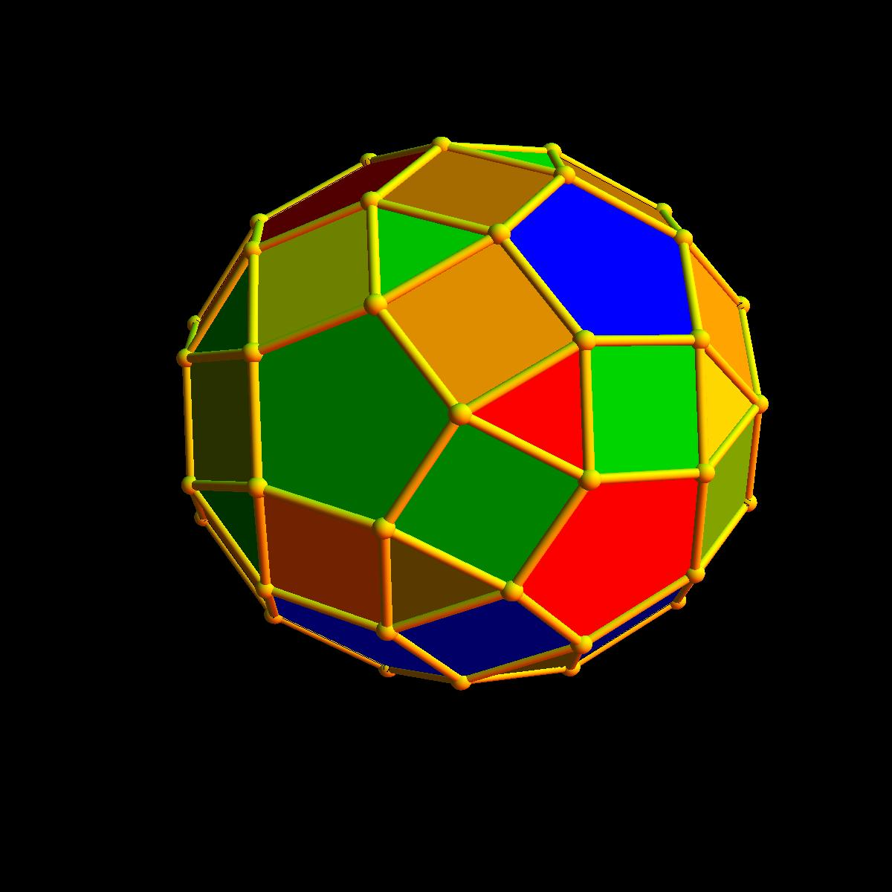

Step 2: Locate the Centers of All Faces
# Source: AI Source: Provided by: [Data Path: Persons Table -> ID Column: 1, Name_En Column: Motasem Essam] -> From: [ChatGPT] on [7/25/2026]
- Construct the center of each triangular face by drawing its medians.
- Construct the center of each square by drawing its diagonals.
- Construct the center of each regular pentagon using its symmetry axes.
- Mark the centers of all 62 faces.
- Ensure that the centers are positioned consistently relative to the reference solid.
These 62 face centers become the vertices of the dual polyhedron.
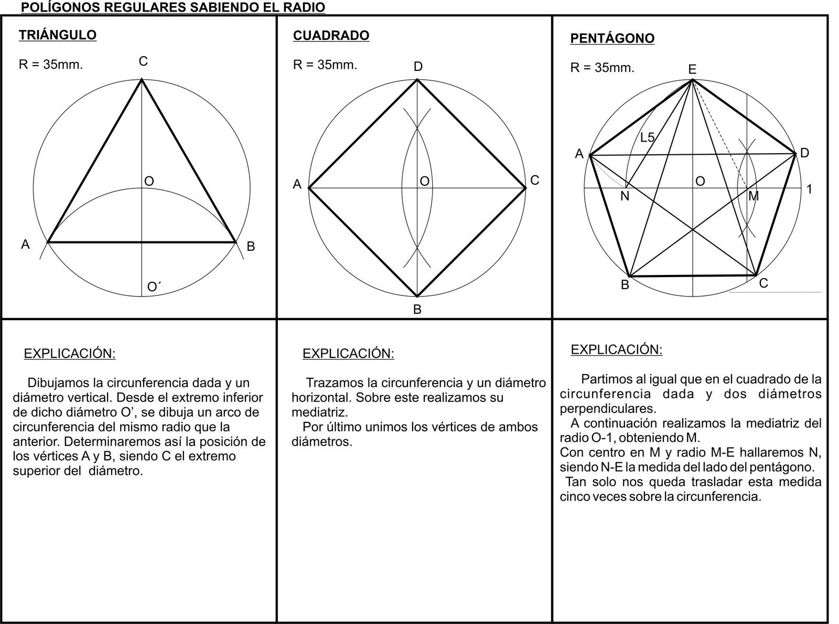

Step 3: Connect the Centers of Adjacent Faces
# Source: AI Source: Provided by: [Data Path: Persons Table -> ID Column: 1, Name_En Column: Motasem Essam] -> From: [ChatGPT] on [7/25/2026]
- Identify every pair of adjacent faces in the reference polyhedron.
- Locate their shared edge.
- Connect the centers of the two faces using a straightedge.
- Repeat for all 120 shared edges.
- Maintain the original face-adjacency pattern.
Each connecting segment represents an edge of the Deltoidal Hexecontahedron.

Step 4: Construct the Kite-Shaped Faces
# Source: AI Source: Provided by: [Data Path: Persons Table -> ID Column: 1, Name_En Column: Motasem Essam] -> From: [ChatGPT] on [7/25/2026]
- Select one vertex of the Small Rhombicosidodecahedron.
- Identify all faces surrounding that vertex.
- Locate the centers of those faces.
- Connect the centers in their cyclic adjacency order.
- Form the corresponding kite-shaped face.
- Repeat this process for all 60 vertices.
Each original vertex produces one kite-shaped face in the dual polyhedron.
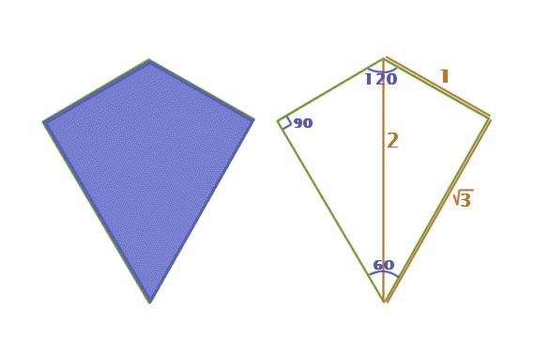

Step 5: Verify the Kite Geometry
# Source: AI Source: Provided by: [Data Path: Persons Table -> ID Column: 1, Name_En Column: Motasem Essam] -> From: [ChatGPT] on [7/25/2026]
- Confirm that all 60 quadrilateral faces are congruent.
- Verify that each face has two pairs of adjacent equal sides.
- Check the proportions between the shorter and longer edges.
- Verify the face angles and symmetry.
- Confirm that all faces fit together without gaps or overlaps.

Step 6: Prepare the Polygonal Faces for Physical Assembly
# Source: AI Source: Provided by: [Data Path: Persons Table -> ID Column: 1, Name_En Column: Motasem Essam] -> From: [ChatGPT] on [7/25/2026]
- Draw one accurate kite-shaped face using a ruler, compass, and protractor.
- Transfer its dimensions to a geometric template.
- Reproduce the face 60 times.
- Mark the corresponding edge connections.
- Arrange the faces according to a verified net or assembly template.

Step 7: Assemble the Three-Dimensional Solid
# Source: AI Source: Provided by: [Data Path: Persons Table -> ID Column: 1, Name_En Column: Motasem Essam] -> From: [ChatGPT] on [7/25/2026]
- Cut out the 60 kite-shaped faces.
- Fold or position the faces along their designated edges.
- Connect adjacent faces according to the verified adjacency arrangement.
- Maintain the required vertex valencies.
- Close the remaining openings.
- Inspect the completed solid to verify its convexity and symmetry.
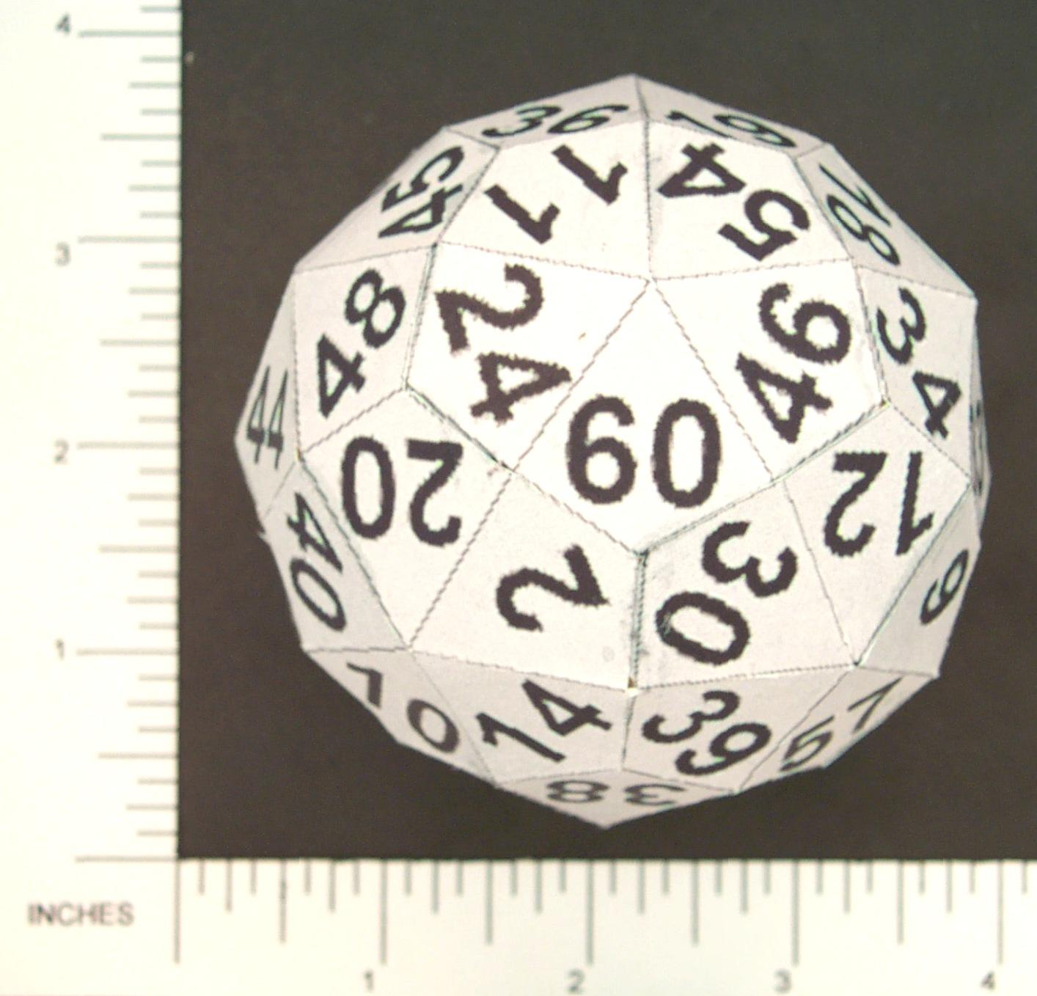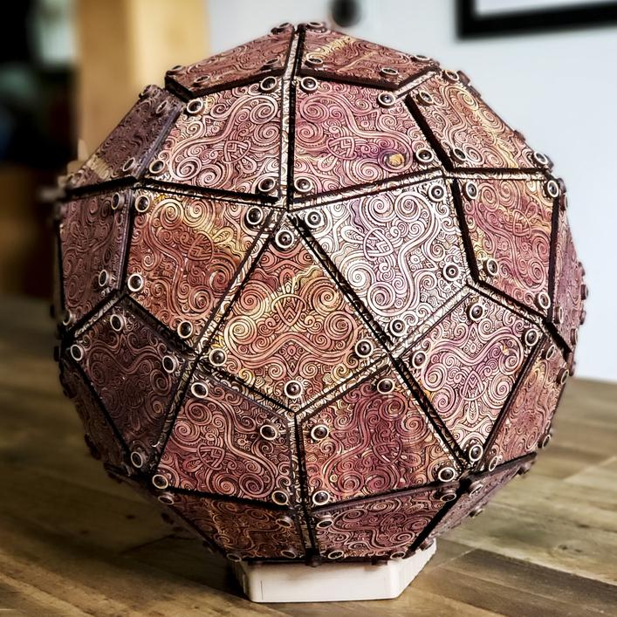

Key Points
# Source: AI Source: Provided by: [Data Path: Persons Table -> ID Column: 1, Name_En Column: Motasem Essam] -> From: [ChatGPT] on [7/25/2026]
- The Deltoidal Hexecontahedron is a convex Catalan solid.
- It has 60 congruent kite-shaped faces.
- It has 120 edges and 62 vertices.
- Its edges consist of 60 shorter and 60 longer edges.
- Its vertices have valencies 3, 4, and 5.
- It has full icosahedral symmetry $I_{h}$.
- Its dual is the Rhombicosidodecahedron.
- It is also known as the Trapezoidal Hexecontahedron.

Main Classification
# Source: AI Source: Provided by: [Data Path: Persons Table -> ID Column: 1, Name_En Column: Motasem Essam] -> From: [ChatGPT] on [7/25/2026]
Solid Geometry
└── Types of Solids
└── Deltoidal Hexecontahedron
├── Kite-Shaped Faces
├── Short Edges
├── Long Edges
├── Vertices
└── Geometric Properties

Conclusion
# Source: AI Source: Provided by: [Data Path: Persons Table -> ID Column: 1, Name_En Column: Motasem Essam] -> From: [ChatGPT] on [7/25/2026]
The Deltoidal Hexecontahedron is a convex Catalan solid characterized by its 60 congruent kite-shaped faces, two distinct edge lengths, and three types of vertices. Its dual relationship with the Rhombicosidodecahedron makes it an important example of dual polyhedra in solid geometry.

